# HIVE and HBASE connection

**1.Create a table in hbase**

create 'sales_table_hbase','sales_details','delivery_details','contact_details'



**2. Create main hive table**

create external table if not exists hive_hbase(

key int,

order_number int,

quantity_order int,

price_each decimal(10,0),

order_line_number int,

sales decimal(10,0),

status varchar(10),

qtr_id varchar(10),

month_id int,

year_id int,

product_line varchar(30),

msrp int,

product_code varchar(15),

phone varchar(30),

city varchar(20),

state varchar(20),

postal_code varchar(15),

country varchar(15),

territory varchar(15),

contact_last_name varchar(50),

contact_first_name varchar(50),

deal_size varchar(50)

)

ROW FORMAT DELIMITED

FIELDS TERMINATED BY ','

STORED BY 'org.apache.hadoop.hive.hbase.HBaseStorageHandler'

WITH SERDEPROPERTIES

("hbase.columns.mapping"=":key,sales_details:order_number,sales_details:quantity_order,sales_details:price_each,sales_details:order_line_number,sales_details:sales,sales_details:status,sales_details:qtr_id,sales_details:month_id,sales_details:year_id,sales_details:product_line,sales_details:msrp,sales_details:product_code,delivery_details:phone,delivery_details:city,delivery_details:state,delivery_details:postal_code,delivery_details:country,delivery_details:territory,contact_details:contact_last_name,contact_details:contact_first_name,contact_details:deal_size")

TBLPROPERTIES("hbase.table.name"="sales_table_hbase");

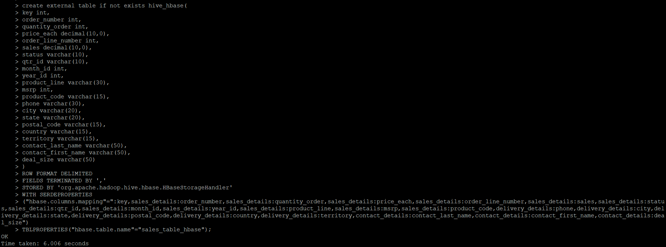

**3. Create a Staging table**

create external table if not exists stage_hive_hbase(

key int,

order_number int,

quantity_order int,

price_each decimal(10,0),

order_line_number int,

sales decimal(10,0),

status varchar(10),

qtr_id varchar(10),

month_id int,

year_id int,

product_line varchar(30),

msrp int,

product_code varchar(15),

phone varchar(30),

city varchar(20),

state varchar(20),

postal_code varchar(15),

country varchar(15),

territory varchar(15),

contact_last_name varchar(50),

contact_first_name varchar(50),

deal_size varchar(50)

)

ROW FORMAT DELIMITED

FIELDS TERMINATED BY ','

TBLPROPERTIES("skip.header.line.count"="1")

;

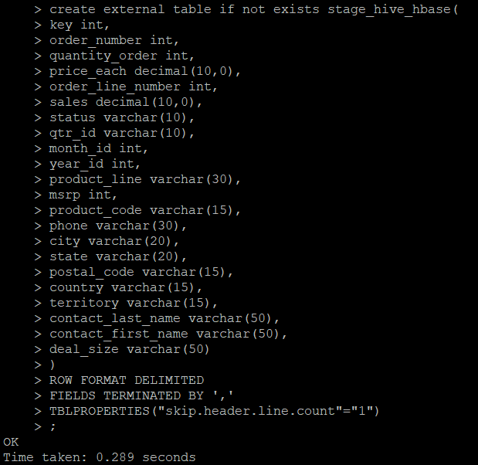

**4.Load data into stage_hive_hbase**

load data local inpath '/home/cloudera/bigdata_projects/sales_order.csv' into table stage_hive_hbase;



**5.Load data into main table from staging**

insert into table hive_hbase select * from stage_hive_hbase;

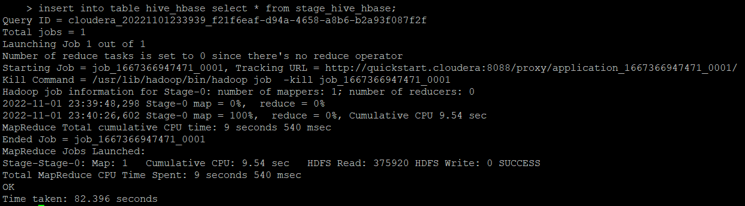

Successfully loaded into hive table

select * from hive_hbase limit 10;

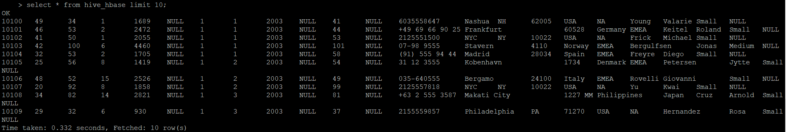

scan "sales_table_hbase"

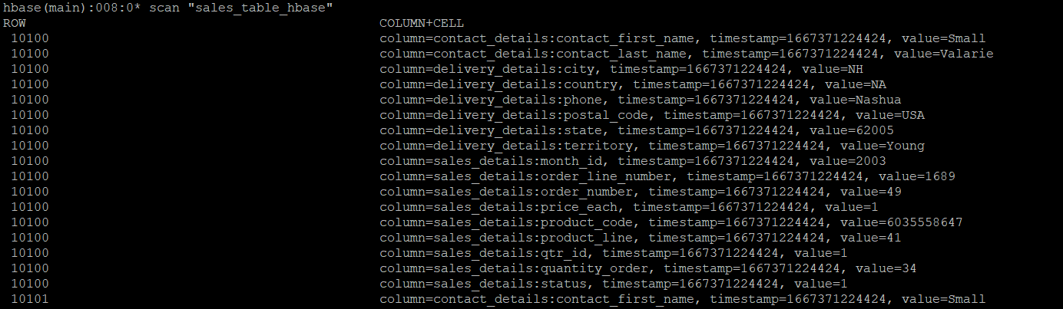

count "sales_table_hbase"

